Project Design Phase-II
Data Flow Diagram & User Stories

Date
Team ID
Project Name
Maximum Marks

Data Flow Diagrams:
A Data Flow Diagram (DFD) is a traditional visual representation of the information flows within a system. A neat and clear DFD can depict the right amount of the system requirement graphically. It shows how data enters and leaves the system, what changes the information, and where data is stored.
Example: Data flow Diagram
Example: (Simplified)
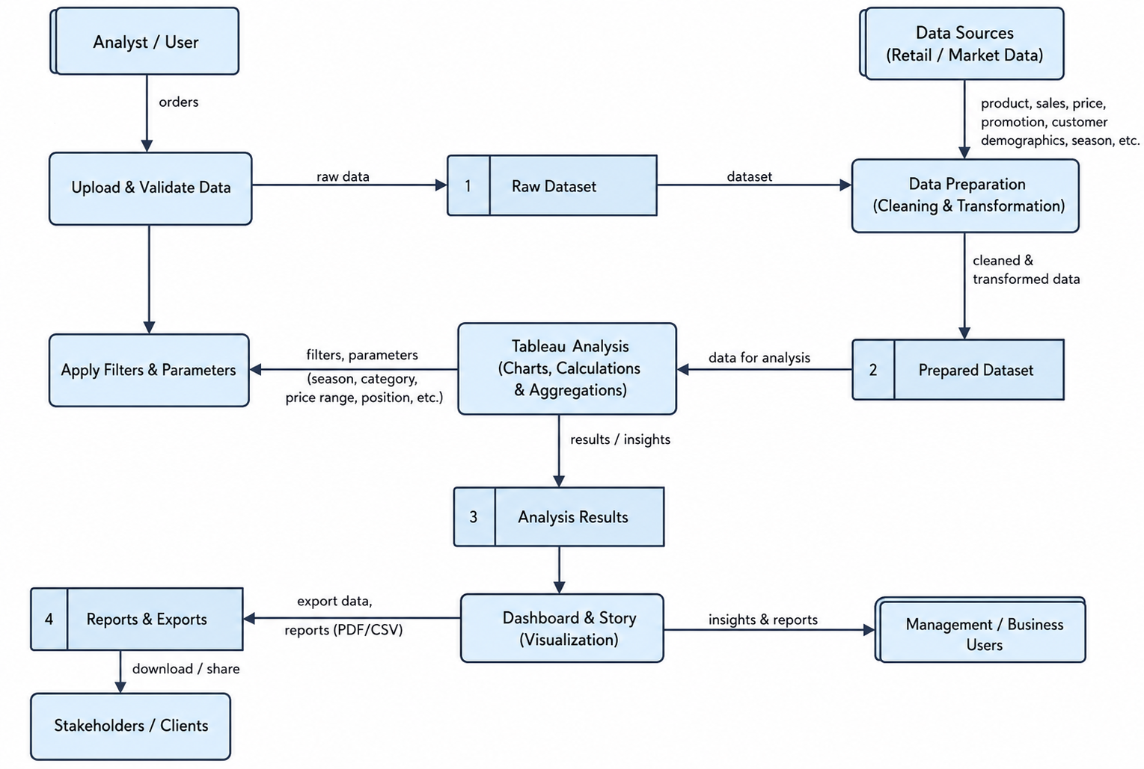
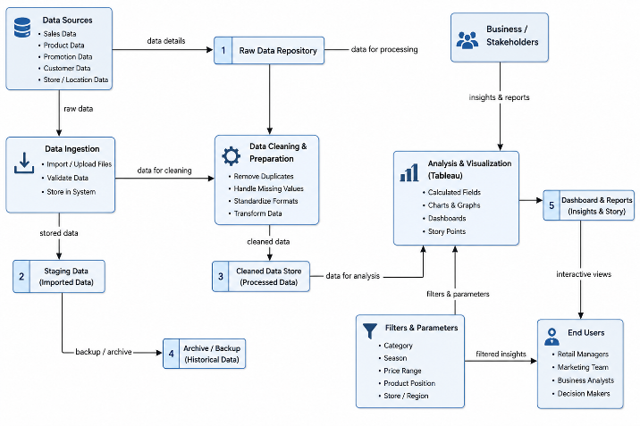

User Stories
Use the below template to list all the user stories for the product.
User Type | Functional Requirement (Epic) | User Story Number | User Story / Task | Acceptance Criteria | Priority | Release
Business Analyst | Dashboard Overview | USN-1 | As a Business Analyst, I want to access the dashboard to monitor overall product placement performance. | Dashboard loads successfully with all visualizations. | High | Sprint-1
Business Analyst | Product Category Analysis | USN-2 | As a Business Analyst, I want to compare average sales volume across different product categories. | Category-wise sales chart is displayed correctly. | High | Sprint-1
Business Analyst | Product Position Analysis | USN-3 | As a Business Analyst, I want to analyze how product placement positions affect sales. | Product position analysis chart is available. | High | Sprint-1
Business Analyst | Seasonal Sales Analysis | USN-4 | As a Business Analyst, I want to compare sales performance across different seasons. | Seasonal sales visualization is displayed correctly. | Medium | Sprint-1
Marketing Manager | Competitor Price Analysis | USN-5 | As a Marketing Manager, I want to compare competitor prices with our product prices. | Competitor price comparison chart is displayed successfully. | High | Sprint-2
Marketing Manager | Consumer Demographics | USN-6 | As a Marketing Manager, I want to analyze customer demographics and purchasing behavior. | Consumer demographics chart is available. | Medium | Sprint-2
Store Manager | Foot Traffic Analysis | USN-7 | As a Store Manager, I want to evaluate the relationship between foot traffic and average sales volume. | Foot traffic vs average sales visualization is displayed. | High | Sprint-2
Product Manager | Product Pricing Analysis | USN-8 | As a Product Manager, I want to compare product categories based on average product prices. | Product category vs price chart is displayed correctly. | Medium | Sprint-2
Marketing Manager | Promotion Impact Analysis | USN-9 | As a Marketing Manager, I want to evaluate the impact of promotional campaigns on product price and sales volume. | Promotion impact visualization is available. | High | Sprint-3
Management | Interactive Dashboard Filters | USN-10 | As a Management user, I want to filter dashboard data by product category, product position, and season. | Dashboard updates dynamically based on selected filters. | High | Sprint-3
Administrator | Tableau Dashboard Publishing | USN-11 | As an Administrator, I want to publish the Tableau dashboard online for stakeholders. | Dashboard is successfully published and accessible online. | Medium | Sprint-3
Administrator | Flask Web Integration | USN-12 | As an Administrator, I want to embed the Tableau dashboard into the Flask web application. | Dashboard loads successfully inside the web application. | High | Sprint-3

